Dis-ME-Israel-Berekhat Ram, Israel, Late Acheulian Female Figurine

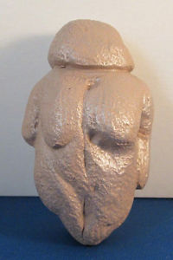 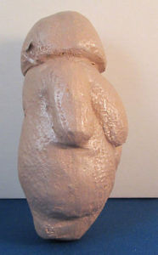 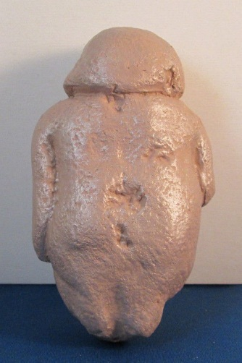 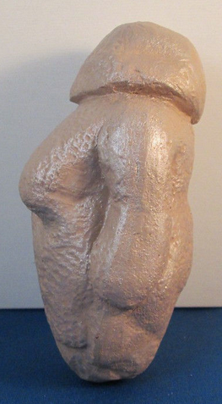

**Formal Label: Israel,** Berekhat Ram, Israel, Late Acheulian Female Figurine

**Accession Number:**

**LC Classification:**

**Date or Time Horizon:** 232,000-800-000 BP

**Geographical Area:** Israel, Berekhat Ram

**Cultural Affiliation:** Late Acheulian

**Medium:** basaltic tuff and scoria pebble

**Dimensions: H** 4.75 in (12 cm)  
**Weight:**

**Provenance:** Hebrew University of Jerusalem's Institute of Archeology

Condition: Museum Replica-Ganges Clay and resin materials- This replica is based on drawings and photographs from the Hebrew University of Jerusalem's Institute of Archaeology, where the original is housed.

Discussion: The famous Willendorf Venus figurine carved from bone 30,000 BP, was thought to be one of the earliest anthropomorphic figurines in existence. This Late Acheulian figurine which bears microscopic traces of human modification predates the Willendorf figurine by 200,000 years and possibly up to 770,000 years. The similarities between the Willendorf figurine and the Late Acheulian figurine are remarkable. Both are distinctly female, great-breasted with featureless heads and distinct limbs. The carver of the Late Acheulian figurine adapted a cobble that already had Venus-like features to which the sculptor added grooves delineating the head and arms. Like the Willendorf figurine, the Late Acheulian figurine appears to have a vulva groove.

References:

Bednarik, R.G., 2006. Lecture No. 3. The evidence of paleoart. *Semiotics Institute Online: Cognition and symbolism in human evolution*.

d'Errico, F. and Nowell, A. 2000. A new look at the Berekhat Ram figurine: implications for the origins of symbolism. *Cambridge Archaeological Journal*, *10*(01): 123-167.

Goren-Inbar, N. 1986. A figurine from the Acheulian site of Berekhat Ram. *Mitekufat Haeven: Journal of the Israel Prehistoric Society/מתקופת האבן*, 7-12.

Hebrew University of Jerusalem's Institute of Archaeology.

Marshack, A. 1997. The Berekhat Ram figurine: a late Acheulian carving from the Middle East. *Antiquity*, *71*(272): 327-337.